**Front-End Engineer Q6**

**Validate:** You need to validate the user entered shape count with available shapes with same type, same color and same size. If it matches then show success message else show failure message.

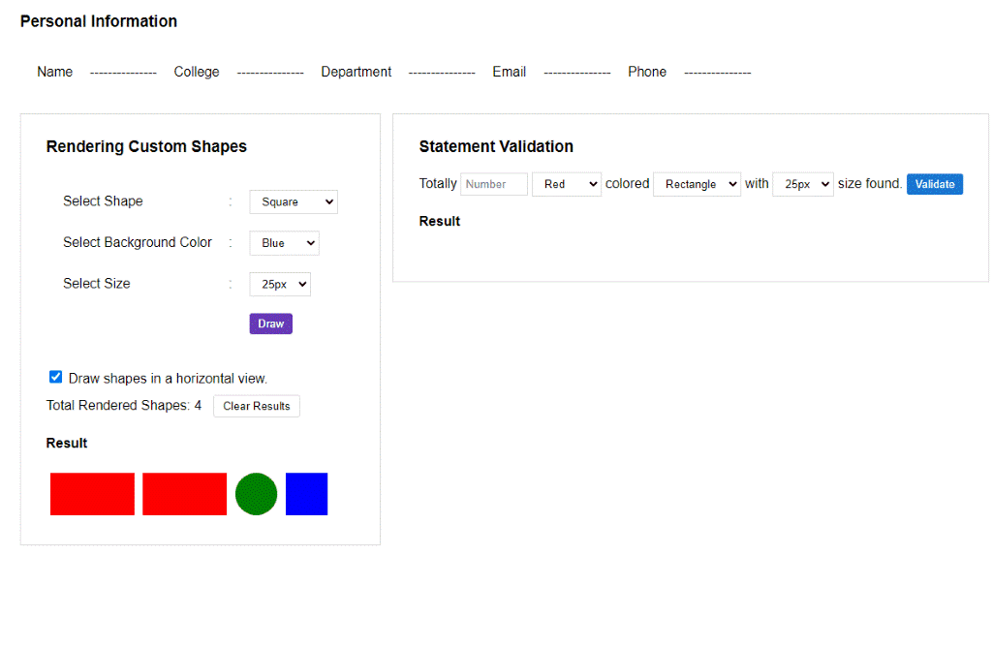

User will enter all the below information as specified in ‘Statement Validation’ frame.

* Total (Total number of drawn items)
* Shape
* Color
* Size

Once the user enters the data, he will press validate. Now you need to verify whether the entered information actually reflects the drawn items.

For example, the below image shows that user entered ‘Totally **2** **Green** colored **Rectangle** with **25 px** size found’. It reflects the actual drawn elements, so when user click ‘Validate’ button we will show ‘Valid Count’ message.

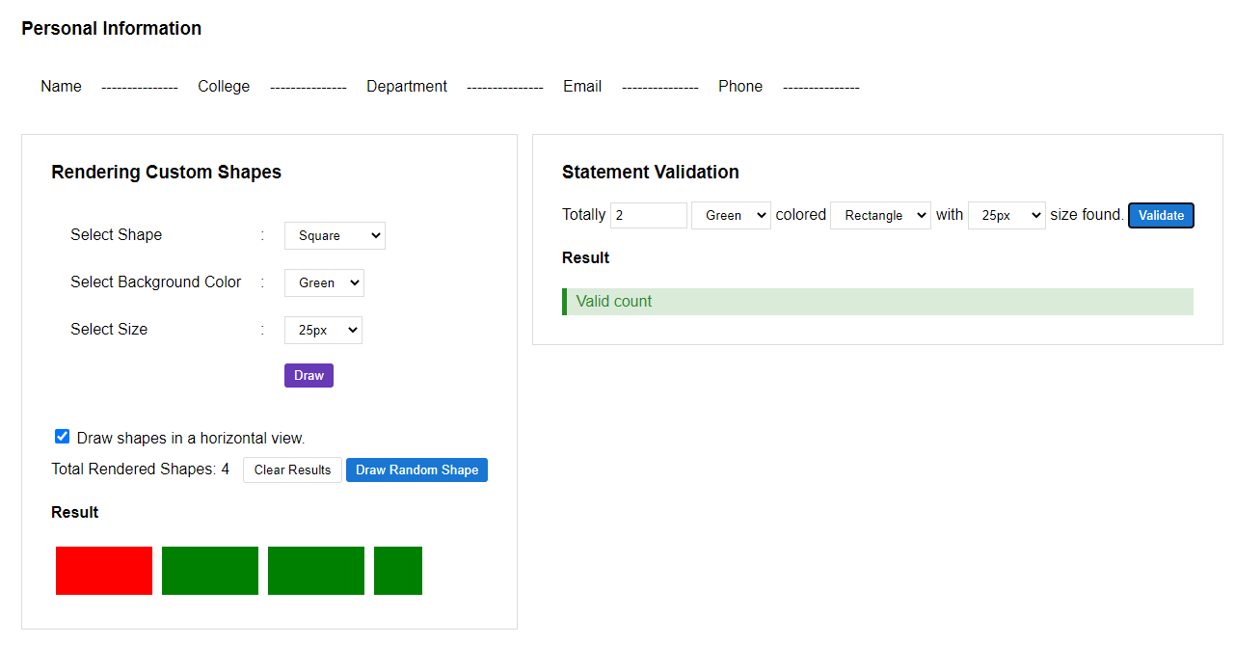

But for the same rendered shapes, the statement ‘Totally **2 Red** colored **Rectangle** with **25px** size found’ is wrong. So, it shows ‘Invalid Statement’ message when user clicks the ‘Validate’ button.

